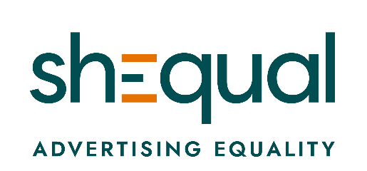

MEDIA RELEASE

For immediate distribution

24 November 2020

shEqual launches to transform advertising in Australia with support from industry and government leaders
shEqual – an Australian first initiative to realise equality in advertising – launched Monday with the support of industry and government leaders.

An initiative of Women’s Health Victoria, CEO Dianne Hill said: “Women’s Health Victoria is proud to launch shEqual. shEqual aims to positively transform Australia’s advertising landscape. I hope shEqual will start a national conversation about how advertising can be a powerful force for driving gender equality and ending violence against women.”

shEqual launches with support from strategic partners in the advertising industry, government and beyond including: Clemenger Group, Respect Victoria, The Shannon Company, OMD Australia, Our Watch, Venus Comms, Marmalade, RMIT University and City of Melbourne.

Remarking on the broad support for shEqual, Ms Hill said: “I look forward to seeing advertising agencies and brands taking the shEqual pledge and committing to changing the advertising they produce, and how they do business. Advertising equality is a benefit to our community and a win for business.”

shEqual is supported by funding from the Victorian Government, with Minister for Women Gabrielle Williams MP launching the brand at the event. Reflecting on the launch, Ms Williams remarked: “The Victorian Government is committed to taking serious action on gender equality. shEqual represents a unique opportunity to work collaboratively with the advertising industry to achieve this outcome.”

CEO of Respect Victoria, Tracey Gaudry, also attended the event, said: “Respect Victoria is proud to be a strategic partner of shEqual and champion this leading initiative with the advertising industry. With 16 Days of Activism against gender-based violence commencing Wednesday, this is a timely reminder of the importance of taking action on gender equality, and the role we can all play – individuals, organisations, industry and government – to achieve a society where everyone is safe, equal and respected.”

Chris Howatson, CEO of CHE Proximity; Priya Patel, Managing Director of DDB Sydney; Martin Cowie, Chief of People at OMD Australia; and Neysa Goh, Head of Marketing – Oceania for the Puma Group joined legendary social commentator and event MC Jane Caro AM for a panel discussion on the future of advertising and equality.

The panel had much to say on how the industry is changing, the role of advertising in driving equality and the important role shEqual will play. “There are huge untapped opportunities brands should be looking at in how we celebrate women” said Priya Patel, Managing Director of DDB Sydney. Reflecting on advertising to women, who are the primary household purchasers, Chris Howatson, CEO of CHE Proximity said: “Change is a necessary requirement. Our role as advertisers, or as people who create brands and shape culture, is to shape [advertising] in a way that is motivating and desirable for our audiences.”

For media inquiries and interviews contact: Alyssa Shaw, Senior Project Officer – Gender Equality in Advertising, 0414 792 540 or hello@shequal.com.au. Visit: shequal.com.au

shEqual is an initiative of Women’s Health Victoria

About Women's Health Victoria
Women's Health Victoria (WHV) is a not-for-profit, statewide women’s health promotion, advocacy and support service, focused on improving the lives of Victorian women. WHV collaborates with women, health professionals, policy makers and community organisations to influence and inform health policy and service delivery for women. The work of WHV is underpinned by a social model of health and a commitment to reducing inequities in health which arise from social, economic and environmental determinants.
For more information, visit whv.org.au

