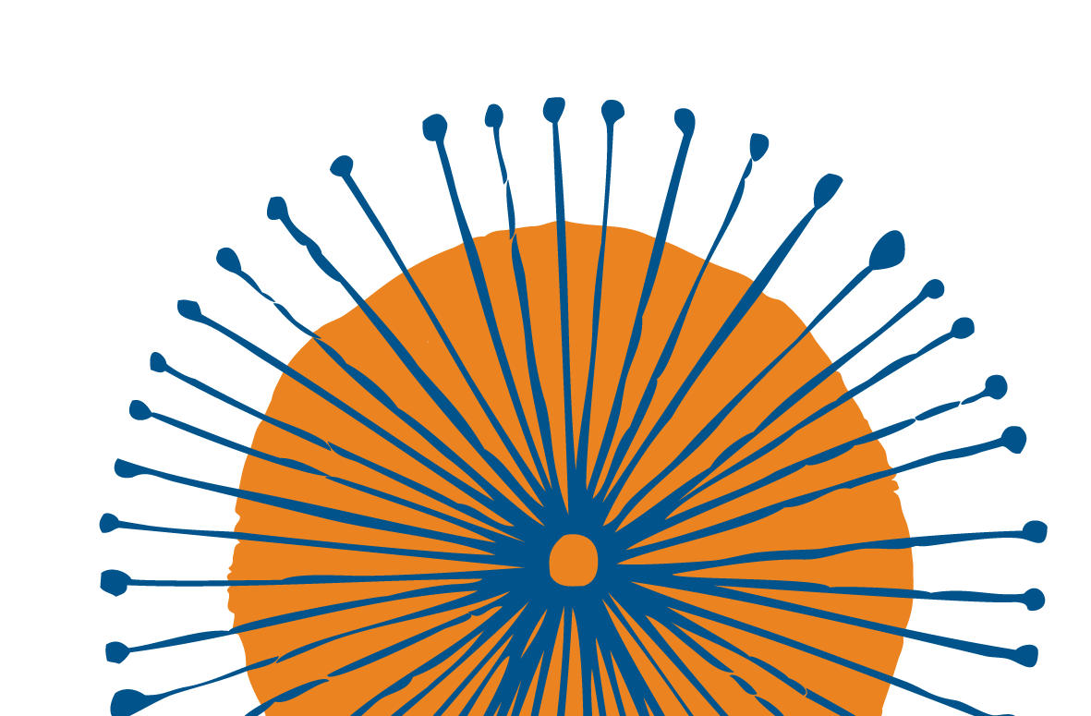

Join international experts in gender equity and gender transformative practice, Lorraine Greaves PhD and Nancy Poole PhD, from the Centre of Excellence for Women’s Health (British Columbia, Canada) for an interactive symposium exploring why sex and gender matter more than ever to effective action on key women’s health issues, with a focus on mental health and substance use.

Drs Greaves and Poole will be joined by Australian experts for a series of workshops that will engage practitioners, researchers, policy makers, and health and social services workers in the use of sex- and gender-based analysis (SGBA+) tools and gender transformative frameworks.
THINK AGAIN:
WHY SEX + GENDER (STILL) MATTER IN WOMEN’S HEALTH

MONDAY 2 DECEMBER 2019
9:30AM - 4:00PM RYDGES MELBOURNE 186 EXHIBITION ST,
MELBOURNE VIC 3000
COST - FREE
eventbrite link for registration

For more information, please contact Phoebe Myatt at Women’s Health Victoria:
phoebe.myatt@whv.org.au
or (03) 9664 9300

This event is presented by Women’s Health Victoria in partnership with VicHealthand Our Watch.

BREAKOUT
SESSIONS
Drs Greaves and Poole are known for their ground-
breaking work on gender equity and gender transformative practice, including Making it better:

1A. Mental health: In the context of the
Royal Commission into Victoria’s Mental Health System, Drs Greaves and Poole will share their experience consulting with the Mental Health Commission of Canada on the importance of considering sex and gender when designing and delivering mental health policy, guidelines and funding. Professor Jayashri Kulkarni will reflect on opportunities to improve women’s mental health in the Australian context.

1B. Substance use: This session will explore the research on sex, gender and substance use, with a focus on tobacco, alcohol, cannabis and prescription opioids. Drs Greaves and Poole will share their world- leading work on women’s substance use in pregnancy and facilitate knowledge exchange between colleagues working in this area in Australia and Canada.

2A. Trauma-informed practice: A knowledge exchange on trauma informed practice across a range of sectors and services, such as mental health and substance use, child welfare, corrections and justice, including case studies from the Canadian and Australian contexts.

2B. Body image: Socially constructed body image ideals - and the valuing of women and girls based on their appearance - have influenced many women to adopt a relationship with their bodies that has little to do with health. This session will explore the significant physical and mental health impacts of these beauty ideals and what a gender-transformative approach to body image might look like.
Gender transformative health promotion (2014), Becoming Trauma Informed (2012), Transforming Addiction: Gender, trauma, transdIsciplinarity (2015) and Gender unchained: Notes from the equity frontier (2017).

The symposium will begin with a plenary presentation from Drs Greaves and Poole, followed by a panel discussion drawing in intersectional perspectives, as well as work on masculinities by Our Watch and VicHealth.

Participants will then choose break-out sessions discussing the importance of sex, gender and gender transformative approaches to mental health, substance use, trauma and body image for women and men.
Participants will work with sex- and gender-based analysis (SGBA+) tools and gender transformative frameworks to consider the impact of these issues in their own settings.

Key speakers include:
Professor Jayashri Kulkarni AM, Monash Alfred Psychiatry research centre
Associate Professor Lucy Burns, National Drug and Alcohol Research Centre, University of New South Wales
Marilyn Beaumont, Australian Women’s Health Network
Dr Shane Tas, Our Watch Natalie Russell, VicHealth
Jackson Fairchild, Rainbow Health Victoria More speakers to be announced!
This symposium will engage practitioners, researchers, policy makers, students, and health and social services workers.

You will leave with inspiration and motivation for action and advocacy, as well as new questions.

