Learning intentions
Students will:
- explore the Victorian Women’s Health Atlas, focusing on community connectedness
- debate the importance of community or wellbeing
- examine the roles of local government and organisations to improve wellbeing in their local area.

Key inquiry questions
How can community connections improve wellbeing?
What does community connection mean?
How can we measure connectedness?
How connected is my community?

Key vocabulary
Community connections
Wellbeing

Time required
Approximately 2 hours

Materials
- Individual access to a computer
- Individual copies of Student Worksheet 2.1 - Community connectedness
- Individual copies of Student Worksheet 2.2 - What is my community doing to improve connectedness?

Prior knowledge
It is assumed that students will have completed Inquiry 1 – Navigating the women’s health atlas.
It is assumed that students will have an understanding of the concept of wellbeing.
It is also assumed that students will know how to complete a PQE (Pattern, Quantify, Exceptions) analysis of a graph or map. Here is a good explanation and practice if required: https://sites.google.com/a/ccw.vic.edu.au/geography-global-wellbeing/home/measuringwellbeing/mappingwellbeing

Readiness checklist
Refer to the Series overview – Teacher Notes

Teacher feedback survey
Feedback is vital to ensure the resource meets teaching and learning requirements in Geography.
After using the resource with students, teachers are invited to complete this feedback survey:
https://www.surveymonkey.com/r/WomensHealthAtlas_GeographyResource
The results will be shared with the resource project partners to inform ongoing updates:
- Women's Health Victoria (WHV)
- Geography Teachers' Association of Victoria (GTAV)

TEACHER INSTRUCTIONS
Sensitive content
Before proceeding with this topic, please refer to the Readiness checklist - sensitive content
(in the Series overview) to ensure you have the necessary support in place.

Starter
- Write ‘community connections’ on the whiteboard and have students provide examples of ways in which people in the community are connected. Write these on the board.
- As a class come up with a definition of ‘community connection’.

Main activities
- Log into the Victorian Women’s Health Atlas: https://victorianwomenshealthatlas.net.au/
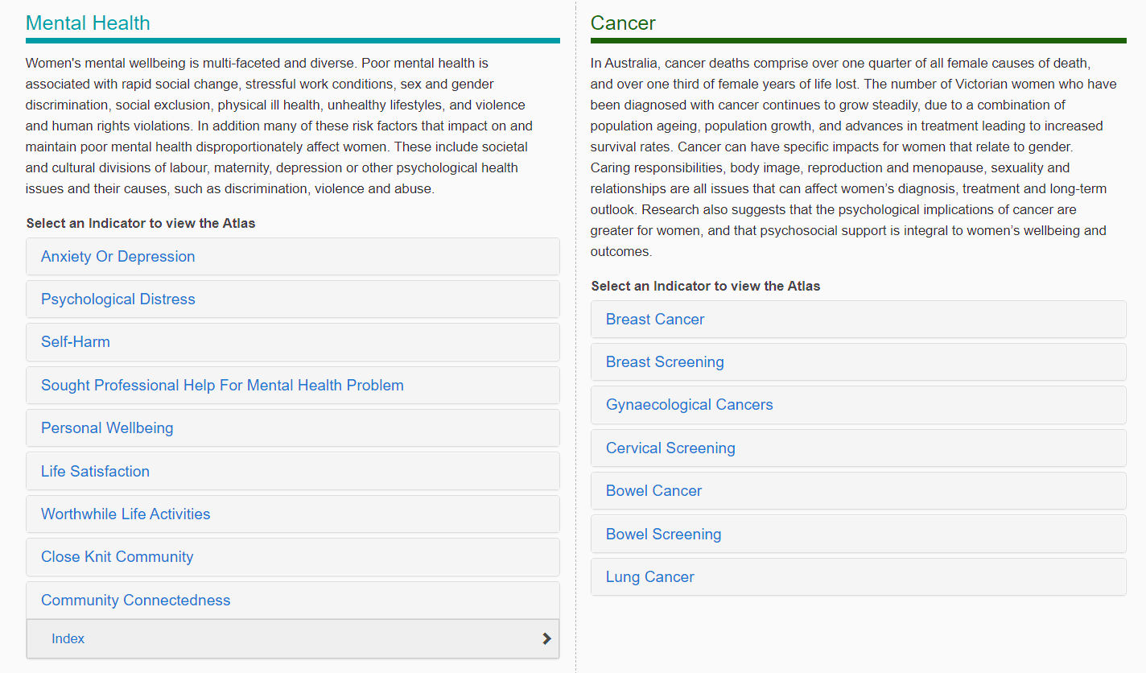
- Have students navigate to the
‘Community Connectedness’ map.
- scroll down to the priority ‘Mental Health’
- select the indicator ‘Community Connectedness’.
- click on the measure ‘Index’.
This should bring up the state map.
The measure is determined by averaging the score given in the community connection domain of the Personal Wellbeing Index Indicator. This score is converted into a scale with a range of 0-100, with 0 being completely dissatisfied and 100 being completely satisfied

- Have students complete the worksheet ‘Community Connectedness’.
This does include completing two PQEs, so you may need to pre-teach it if this is a new skill.
Discuss their findings and highlight these key points to students:
- men have a lower community connectedness than women, and
- people in metropolitan areas feel less connected than those in rural and regional areas.
- Have students conduct a class debate on one of the following topics:
- Gender stereotypes mean that women are more connected to community than men.
- Local communities are becoming less important for social connection these days because of social media.
- Social media enables people to make and maintain connections outside their local area.
Divide the class into opposing sides and have them each brainstorm three points of view for their team.

- Have students explore the local government and community initiatives in your school LGA to improve wellbeing.
Firstly, brainstorm with the class any community programs, events or services in the area. Suggestions include: community or senior citizens centre, street parties or festivals, local arts prizes or festivals, library story time, local markets, sports clubs etc. The council website is a great place to start, or the local newspaper.
Have students choose one and use the worksheet ‘What is my community doing to improve connectedness in my community?’ to guide them.
Students could create short presentations to share with the class.

Plenary
Have students make suggestions about programs, events or services that could be included to improve wellbeing in their community.

Differentiation
For less able students:
Select appropriate services or programs for these students to investigate as choice can often be overwhelming. Have these students do their local LGA for Task B of the Community Connectedness worksheet.
For more able students:
Get a copy of the local health and wellbeing plan from your local council - does it have any actions around this? Encourage these students to debate for the opposing side to challenge their thinking. Have students choose two similar services and compare them. These students could also choose another LGA to investigate and compare their services.

Suggested adaptations
- The debate could be structured as a line debate or Philosophical Chairs discussion to encourage participation.
- Have students explore the role of social media on community connectedness. Are there specific programs or pages that facilitate connectedness? (Think Meetup or a local ‘Buy Swap Sell’ group).
- Students could conduct community surveys on the services and programs available in their area. They could make recommendations to the local council on any gaps they find.

Further reading
Relationships Australia (2022) Strong relationships, strong health. Victoria. Department of Health and Human Services. Melbourne – (Better Health Channel Factsheet). Available at: https://www.betterhealth.vic.gov.au/health/HealthyLiving/Strong-relationships-strong-health
Australia. Department of Health (2022) Connecting with community. Australia. Department of Health. Canberra. – (Head to Health). Available at: https://headtohealth.gov.au/meaningful-life/connectedness/community

VicHealth (2019) Loneliness and social isolation a growing health risk for young Australians. VicHealth Media Release (Oct 1). Available at: https://www.vichealth.vic.gov.au/search/loneliness-and-social-isolation-a-growing-health-risk-for-young-australians
VicHealth (2016) Improving mental wellbeing: Local government action guide. Victorian Health Promotion Foundation. Carlton South. p. 3. Available at: https://www.vichealth.vic.gov.au/-/media/VHIndicators/MWB---LGA-Action-Guide.pdf
Swinburne University. Centre for Regional Development and McCaughey Centre (2007) Community Indicators Victoria: a resource guide: using CIV as a tool for Council planning. McCaughey Centre. Melbourne. Available at: https://naaee.org/sites/default/files/civresourceguide.pdf

Philosophical Chairs discussion
Jimenez A (2021) An engaging critical thinking activity: philosophical chairs. Communication By Design. Grand Rapids, MI. Available at: https://cbdconsulting.com/free-resources/articles/an-engaging-critical-thinking-activity-philosophical-chairs/
(2020) Philosophical chairs discussion. BetterLesson.com. Available at: https://betterlesson.com/strategy/6
Fletcher J (2019) A framework for whole-class discussions. Edutopia (May 7). Available at: https://www.edutopia.org/article/framework-whole-class-discussions

STUDENT WORKSHEET 2.1
Community connectedness
Go to the Victorian Women’s Health Atlas website: https://victorianwomenshealthatlas.net.au

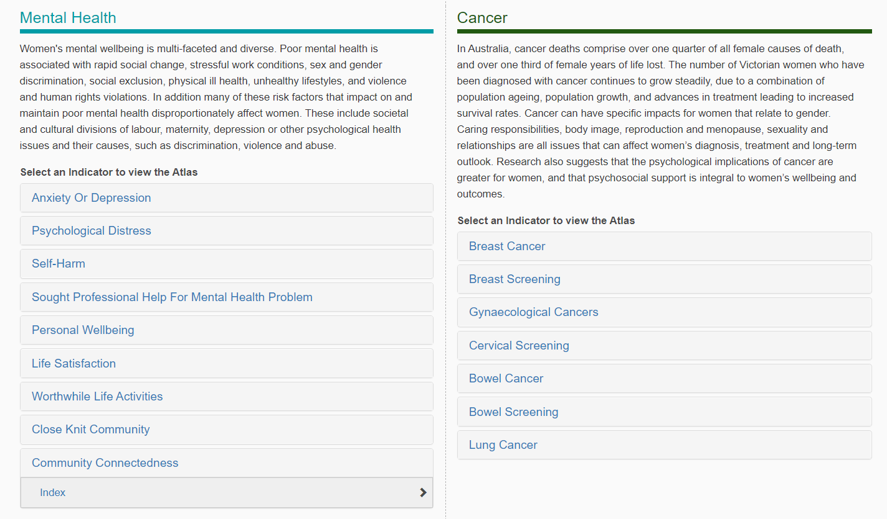
TASK A

Scroll down to the priority ‘Mental Health’
Select the indicator ‘Community Connectedness’
Click on the measure ‘Index’.

This should bring up the state map. Explore the map – toggle between male and female
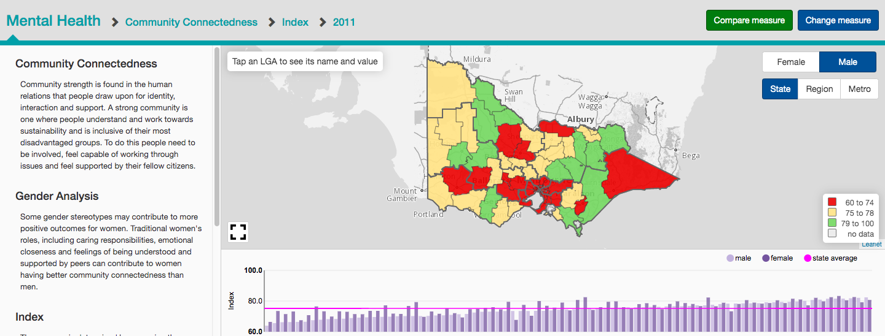

Complete the following tasks:

A1. Complete a PQE table for female Community Connectedness in 2011.
Pattern (e.g. radial, clustered, random)
Quantify (provide examples of facts and figures, names of regions etc.)
Exceptions (outline any exceptions to the above pattern)

A2. Using the same table as above, write a PQE paragraph for male community connectedness in 2011.
A3. What differences do you notice between the levels of Community Connectedness of males and females in Victoria?
A4. What reasons can you provide for any differences observed?
A5. What do you notice about the difference between Community Connectedness in metropolitan areas as compared with regional and rural areas? Why do you think this is?

TASK B
Choose an LGA and click on it. (Brimbank used here as an example)
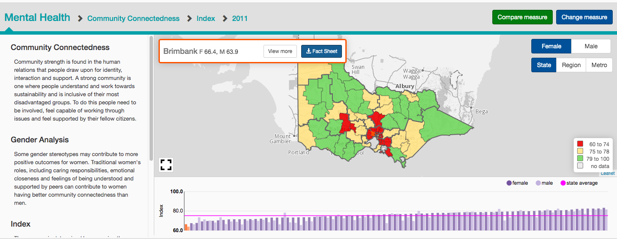
Click ‘Fact Sheet’ to download more information.

The fact sheet contains data for every indicator within the Mental Health group.
Using the fact sheet, answer the following questions for your chosen LGA.
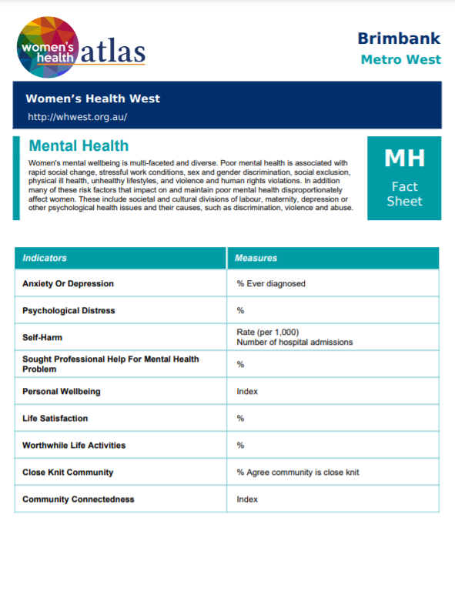
Questions
B1. What other challenges do people with poor mental health face?
B2. Scroll to Personal Wellbeing Indicator.
The Personal Wellbeing Indicator uses seven different domains to determine the measure. What are they?
B3. What is the Personal Wellbeing Indicator for your LGA?
Is this above or below the state average?
By how much?
B4. Scroll to Community Connectedness Indicator.
What is measured by this indicator?
B5. What is the Community Connectedness 2011 Index for
your LGA?
B6. Compare this to the state average – is it higher or lower?
By how much?
B7. Why do you think it is different to the state average?

TASK C
Go to the Department of Health website ‘Head to Health’:
https://headtohealth.gov.au/meaningful-life/connectedness/community

Questions
C1. What are the benefits of community involvement?
C2. What percentage of Australian people are not involved in any social or community group?
C3. What are some suggested activities to improve your sense of belonging to community?

STUDENT WORKSHEET 2.2
What is my community doing to improve connectedness?

In your home area, investigate one local community initiative, event, program or service.
Consider and complete the following:

Title of initiative, program, event or service: _____________________________________________
___________________________________________________________________________________

1. Describe the initiative, program, event or service: What does it provide? Who does it cater to?
Who is included and who might be excluded (age groups, gender, etc.)? What is it intending to do?

- Apart from services – what else contributes to a sense of connection?
e.g. murals (public art – validation from seeing your demographic represented);
built environment (safety such as lighting, security);
access (ramps, baby friendly, public transport).

- How could it help with community connectedness? (Consider accessibility, language, cost, timing?)

- How could it help improve wellbeing?

- Do you think this is a good initiative, program, event or service? Why/why not?

- How would you change or alter the initiative, program, event or service to improve it?

