Learning intentions
Students will learn how to use the Victorian Women’s Health Atlas (The Atlas).
Students will explore some key ideas of adolescent birth and gender pay gaps.

Key inquiry questions
Why was the Victorian Women’s Health Atlas created?
What information can I learn from the Atlas?

Key vocabulary
Local Government Area (LGA) | Victoria is divided into 79 municipalities (34 cities, 38 shires, 6 rural cities, and  1 borough), each with an elected Council to manage local issues such as building regulations, waste management, parks and gardens and pet control.
Priority Health Areas | Broad themes under which The Atlas content is grouped.
Indicator | A population characteristic that can be measured – often selected to describe an aspect of health or wellbeing – e.g. Perceptions of Safety, Anxiety and Depression, Adolescent Birth, Unpaid Domestic Work.
Measure | A standard unit used to express the size, amount, or degree of something,  – e.g. the number of victim reports, the percentage of people who participated,  the rate of births per 1,000 women.
Count | The total number (of persons, notifications, services etc.) within a given time period.
Rate | The total number divided by a common denominator – often 1000 or 10,000.  This allows for comparison between areas of differing populations.

Data processing notes
When looking at and using data, it is always preferable to check its reliability. Ask these questions about the data:
- where did the data come from?
- who created it?
- at what scale was it created?
- is it curated?
- is it trustworthy?
These are elements that are especially important in mapping. Asking these questions means you are being critical of the data. To make effective use of maps, make sure you understand these elements and therefore, the map limitations.
On the lower left of each indicator map you will find information on the source of data, its currency and a link to the source. Also, when you download the fact sheets, you can find when the data was last updated.

Time required
Approximately 1 - 1.5 hours

Materials
- Individual access to a computer
- Post-it notes
- Individual copies of Student Worksheet 1 – Scavenger Hunt

Readiness checklist
Refer to the Series overview – Teacher Notes

Teacher feedback survey
Feedback is vital to ensure the resource meets teaching and learning requirements in Geography.
After using the resource with students, teachers are invited to complete this feedback survey:
https://www.surveymonkey.com/r/WomensHealthAtlas_GeographyResource
The results will be shared with the resource project partners to inform ongoing updates:
- Women's Health Victoria (WHV)
- Geography Teachers' Association of Victoria (GTAV)

TEACHER INSTRUCTIONS
Sensitive content
Before proceeding with this topic, please refer to the Readiness checklist - sensitive content
(in the Series Overview) to ensure you have the necessary support in place.

Starter
- Pre-teach the students the vocabulary they will be exposed to in this lesson. You could write up definitions or do a simple mix and match activity.
- Show students the video under ‘How to use the atlas’ on the front page of the atlas:
https://victorianwomenshealthatlas.net.au/

Main activity
- Have students explore The Atlas and find facts to share with the class. These should include a statistic or location – they can be stand-alone statistics or comparative ones. If they find an interesting (or outrageous) fact, they should write it on post-it notes and stick it around the room.
- Have students walk around the room and read the facts. You could award the most outrageous fact found.
- Provide students with the Student Worksheet 1: Scavenger Hunt.

Plenary
- Go through the answers and have a class discussion around the issues raised. Some suggested discussion questions:
- What surprised you?
- Did you notice a connection between adolescent birth rates and education?
- Why are there so few women in leadership roles?
- Why is it called the Victorian Women’s Health Atlas if it includes data on men and women?
- Why do you think The Atlas was created?

Differentiation
For less able students:
For the initial activity, provide these students with a topic or two to focus on such as vegetable consumption or physical activity (in Avoidable Mortality), or birth rates (in Sexual and Reproductive Health). For the worksheet, provide students with the answers to Task D. They could use it to complete Task E if they felt confident.
For more able students:
Have students choose another indicator such as poverty or individual weekly income to explore in relation to education. Have them make a prediction of what they expect to see, and any correlation with education. For example, if they select poverty then have them predict which regions would have a higher (or lower) level of poverty. Do they expect to see any correlation with education? Have them go and explore the indicator and check their predictions.

Suggested adaptations
- Have half the class complete Task C, and half complete Task D (all should complete A and B).
- Pair students up so that in each pair is one who has done C, and one who has completed D. Have the students share their answers and complete Task E together.
- If time (or the class) doesn’t allow, complete the fact-finding mission individually at the end of the lesson and just have students write them down.
- You could have students write down three ‘take-aways’ from the lesson – three things (facts or ideas) that stuck in their heads.

Further reading:
Workplace Gender Equality Agency (2022) Australia’s gender pay gap statistics. WGEA. Sydney. Available at: https://www.wgea.gov.au/data/fact-sheets/australias-gender-pay-gap-statistics

Hislop M (2022) Australia’s gender pay gap drops slightly to 13.8 per cent Women’s Agenda (Feb 24). Available at: https://womensagenda.com.au/latest/australias-gender-pay-gap-drops-to-13-8-per-cent/
(2018) Fact check: have women become better educated whilst the gender pay gap hasn't budged? RMIT ABC Fact Check (Jul 16). Available at: https://www.abc.net.au/news/2017-08-02/fact-check-women-education-gender-paygap/8760614
Livsey A (2017) Australia’s gender pay gap: why do women still earn less than men? The Guardian (Oct 18). Available at: https://https://www.theguardian.com/australia-news/datablog/2017/oct/18/australia-gender-pay-gap-why-do-women-still-earn-less-than-men

STUDENT WORKSHEET 1:
Scavenger hunt
Go to the Victorian Women’s Health Atlas website: http://victorianwomenshealthatlas.net.au

TASK A
Scroll down to the priority ‘Sexual and Reproductive Health’.

Select the indicator ‘Adolescent Birth’.
Click on the measure ‘Aggregate 2 year rate (per 1,000)’.
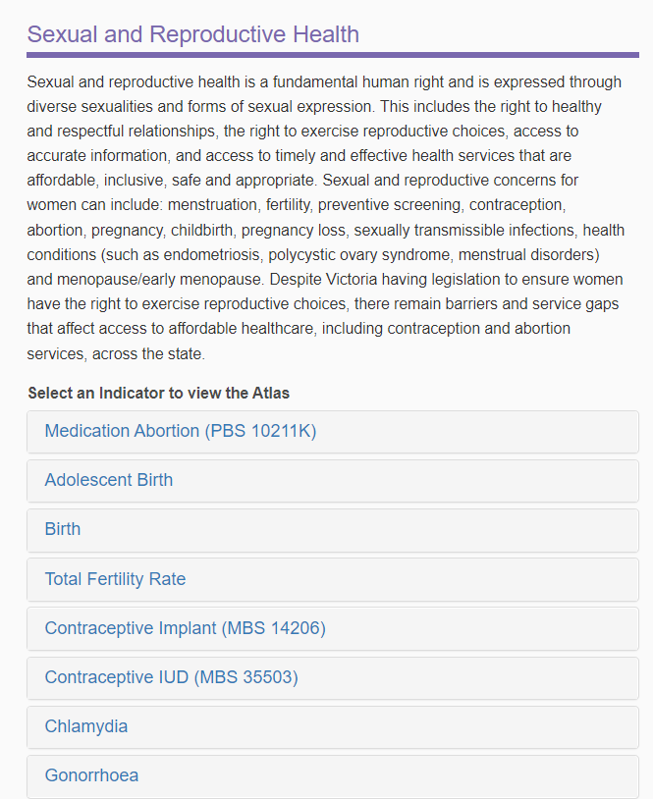

This should bring up the state map.
Note that you can explore the changes to adolescent birth over time by using the slider to select maps from earlier or later years.
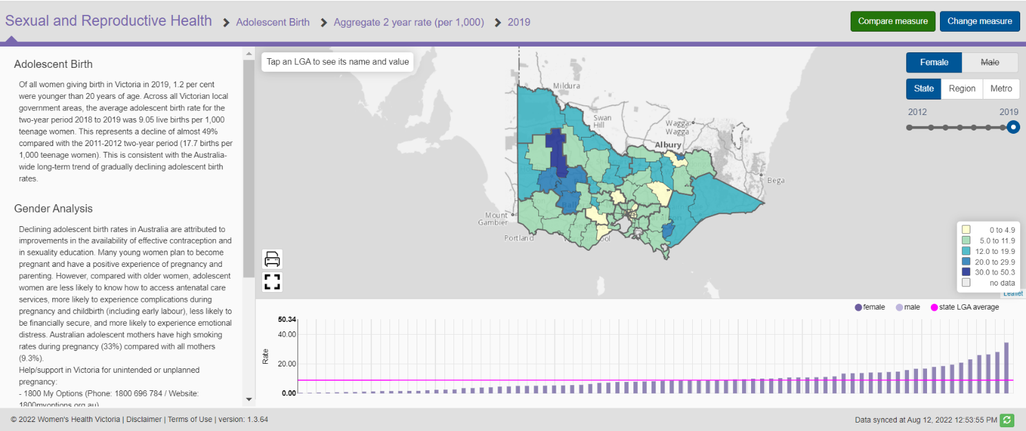

Questions
A1. The left-hand side of each map contains a description of data collection as well as gender analysis – read this information. With a partner discuss some of the difficulties that might be experienced by some adolescents who become pregnant.
A2. Investigate and describe the change in adolescent birth rates in Victoria over time. What reasons are given for this change?
A3. Identify and list three LGAs with a high rate of adolescent birth.
A4. Click ‘Metro’ on the right-hand side. What is the adolescent birth rate in Melbourne LGA?
A5. How have adolescent birth rates changed in ‘Metro’ over time?
A6. What is the adolescent birth rate in your LGA?

TASK B:
Go back to State view. Which LGA has the highest rate of adolescent birth? Click on this LGA
HINT: Use the bar graph to identify and highlight the highest for you.
(Ararat LGA used here as an example only)
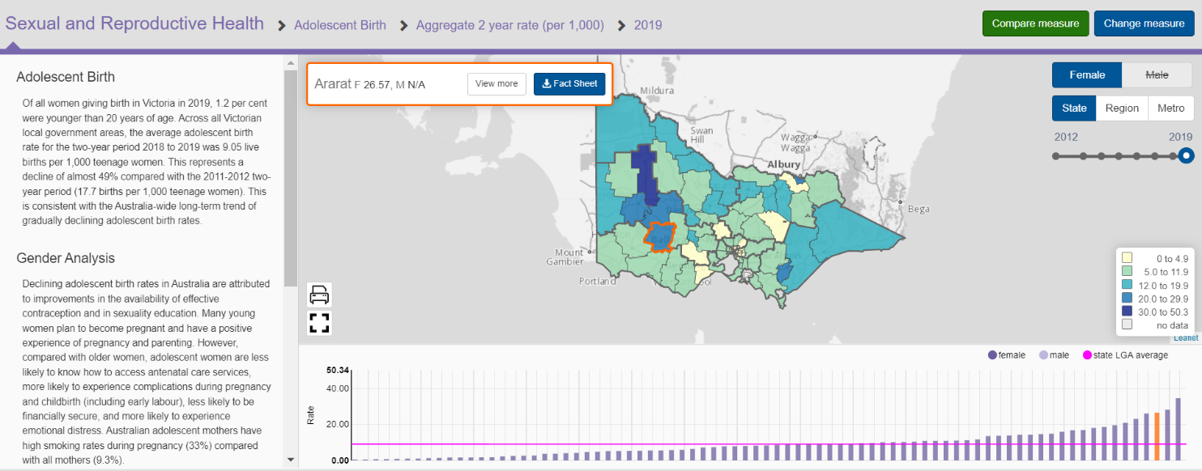

Download the fact sheet. The second indicator in the fact sheet is ‘Adolescent Birth’.
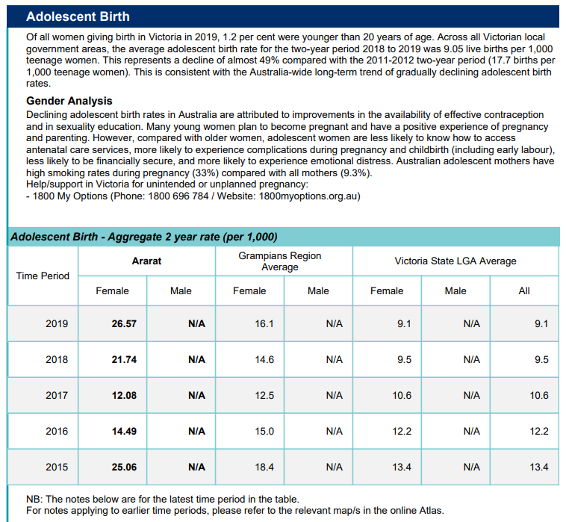

Questions
B1. With a partner, describe how adolescent birth changed between 2014-2015 and 2018–2019 in the LGA with the highest rate of adolescent birth. Use statistics to support your answer.
B2. How old is this data? If the current trend continues, what do you expect the adolescent birth rate to be for 2019–2020 and into the future? Compare this trend with the statewide trend.

TASK C
Click ‘Change measure’ in the top right corner
Select the priority ‘Gender Equality’.
Select the indicator ‘Education’
Select the measure ‘% Attained Year 12 or equivalent’. Then click ‘Show for Female’.
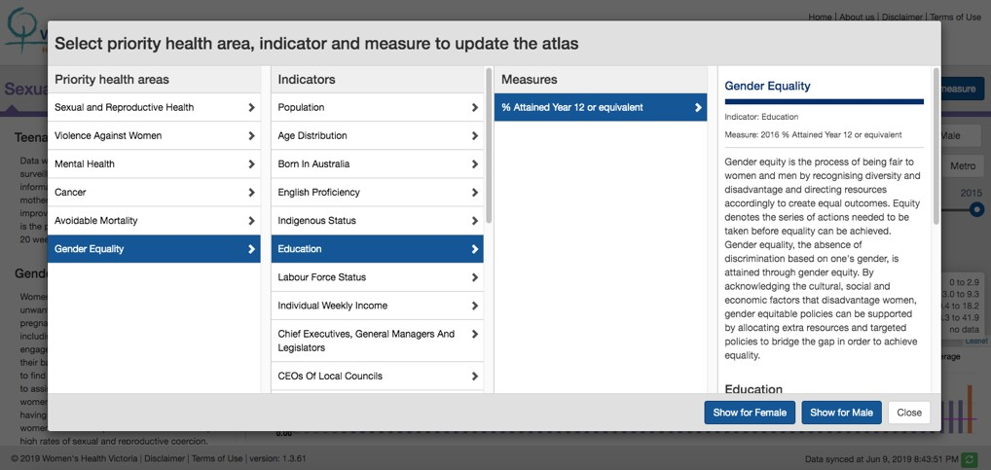

Explore the map – toggle between male and female and compare 2011 to 2016
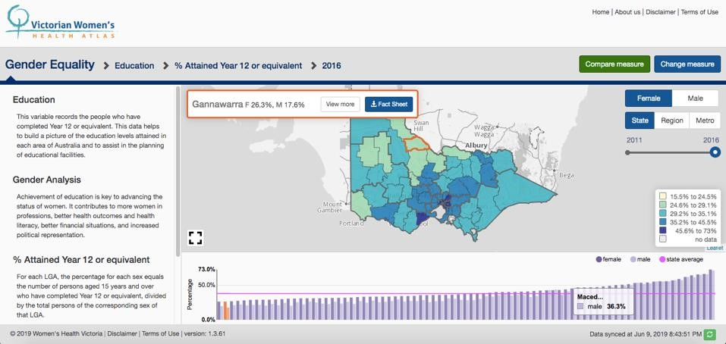

Questions
C1. What differences do you notice between the education levels of males and females in Victoria?
Why do you think this is?
C2. Use the slider to toggle between 2011 and 2016. Identify the main difference between these years in the education of women.
C3. Given that overall females have a higher rate of completing Year 12, what would you expect to see regarding income levels, job types, poverty rates etc.?

TASK D
Click ‘Change measure’ in the top right corner.
Select the priority ‘Gender Equality’.
Select the indicator ‘Chief Executives, General Managers and Legislators’.
Select the measure ‘% Proportion that are female or male’. Then click ‘Show for Female’.
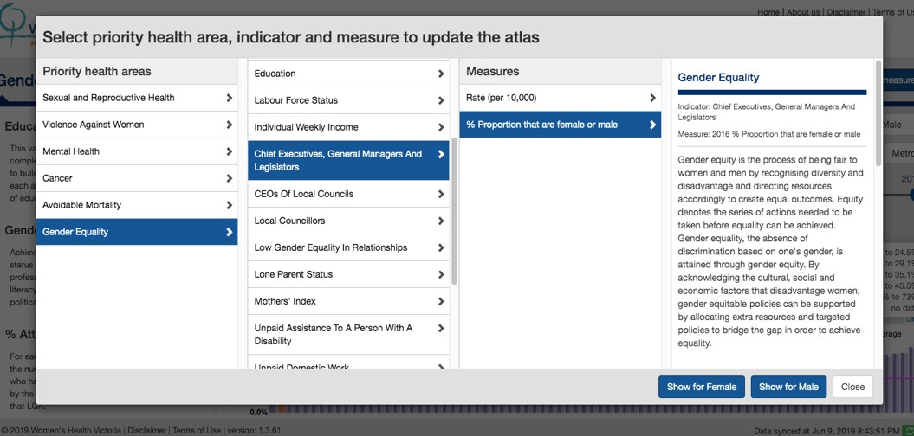

This map shows the gender breakdown of women in leadership roles.
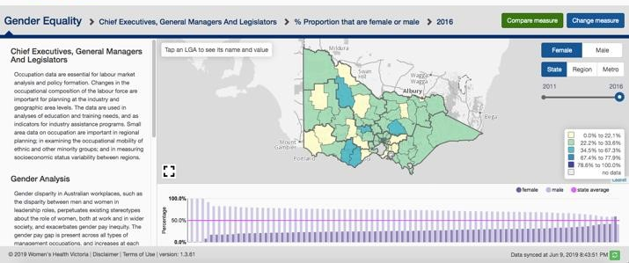

Questions
D1. How many LGAs have more women than men in positions of Leadership? Identify them.
D2. Which LGAs have the lowest rate of women in Leadership roles?
D3. Read the information on the left. In your own words, what are some of the associated problems with this imbalance?

TASK E
Lastly, we will examine these two maps side by side.
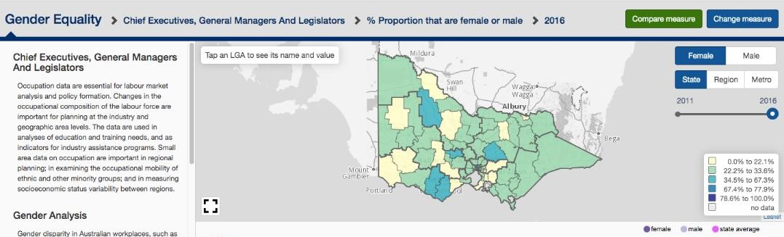

Click ‘Compare measure’.

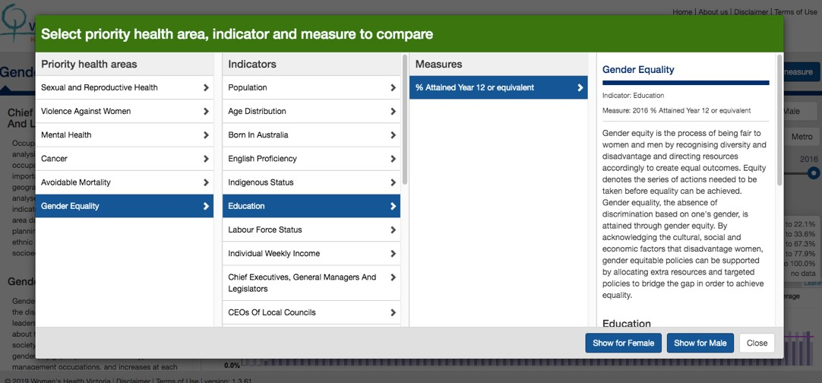
Select the Priority Health Area ‘Gender Equality’.
Select the indicator ‘Education’.
Select the measure ‘% Attained Year 12 or equivalent’.
Then click ‘Show for Female’.

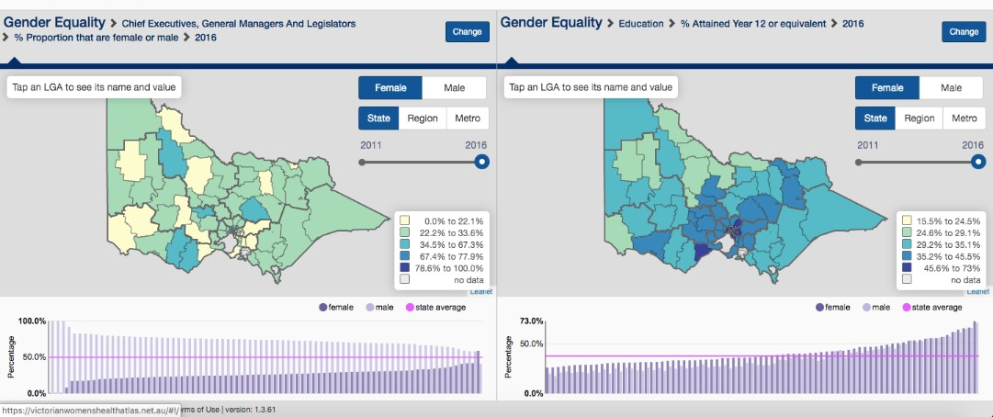
You should now have the two maps side by side.

Questions
E1. Choose one LGA. Provide the measure in each category. How do they compare?
E2. What do you notice about the correlation between education and positions of leadership in general?
E3. Why do you think this is so?

